- Adding a Domain Controller to an existing Domain

Step 1: In Windows Server Manager Add Roles & Features Select AD DS Role
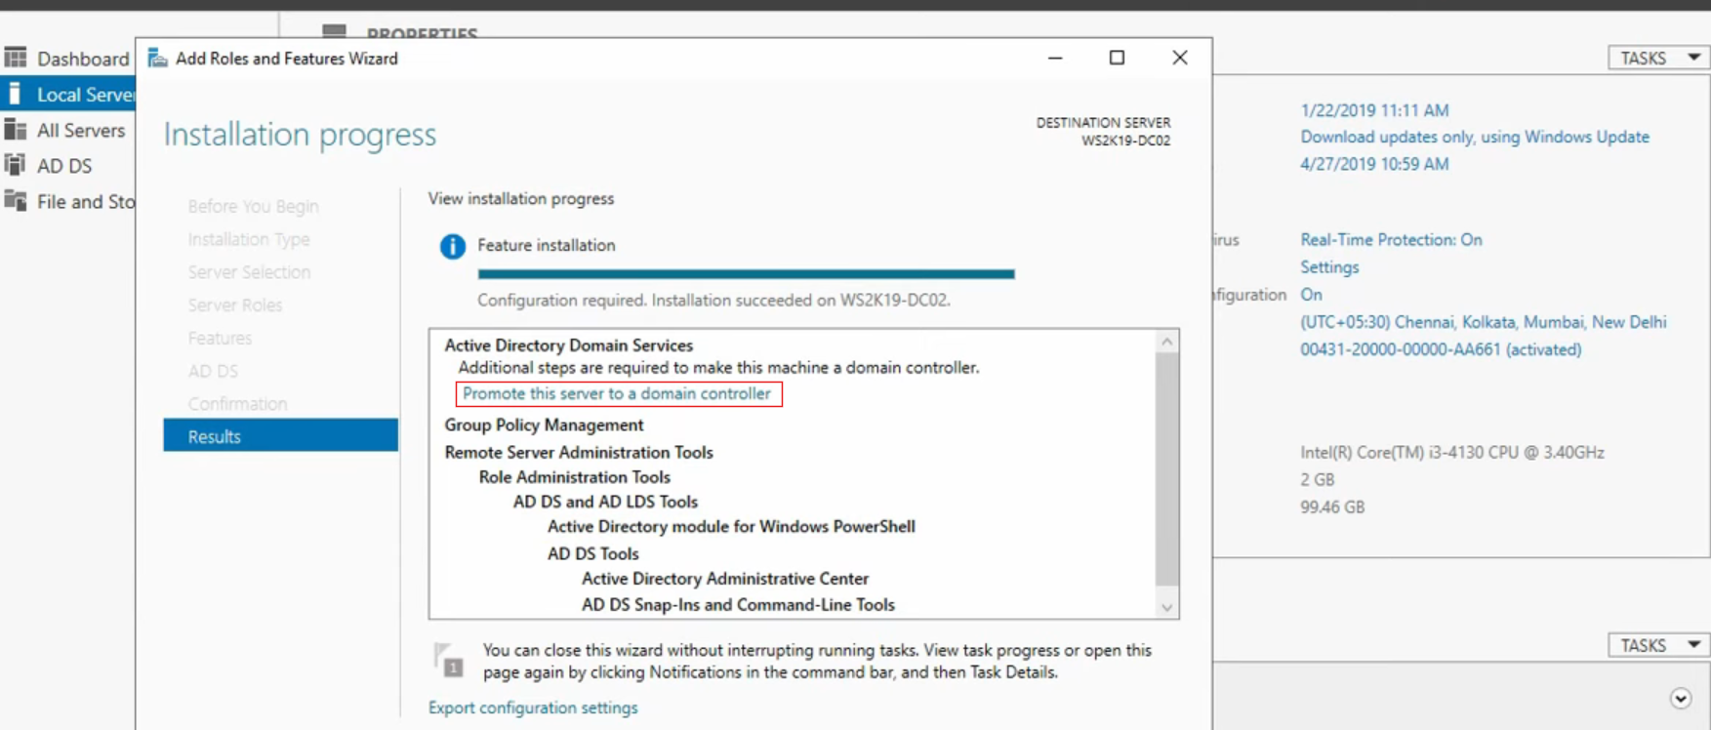
Step 2: After Installing ADDS Role in Windows Server, click on “Promote this server to a domain controller”
Step 3: In Active Directory Domain Services Configuration Wizard Under Deployment Configuration Select “Add a domain controller to an existing domain”
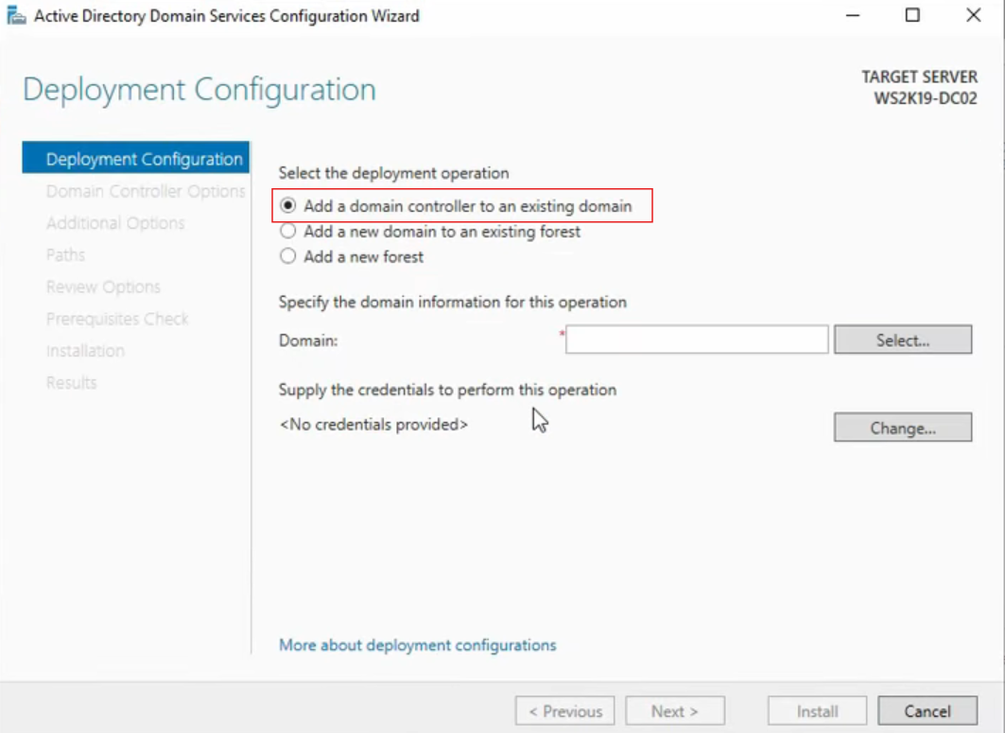
Step 4: Enter your Administrator credentials
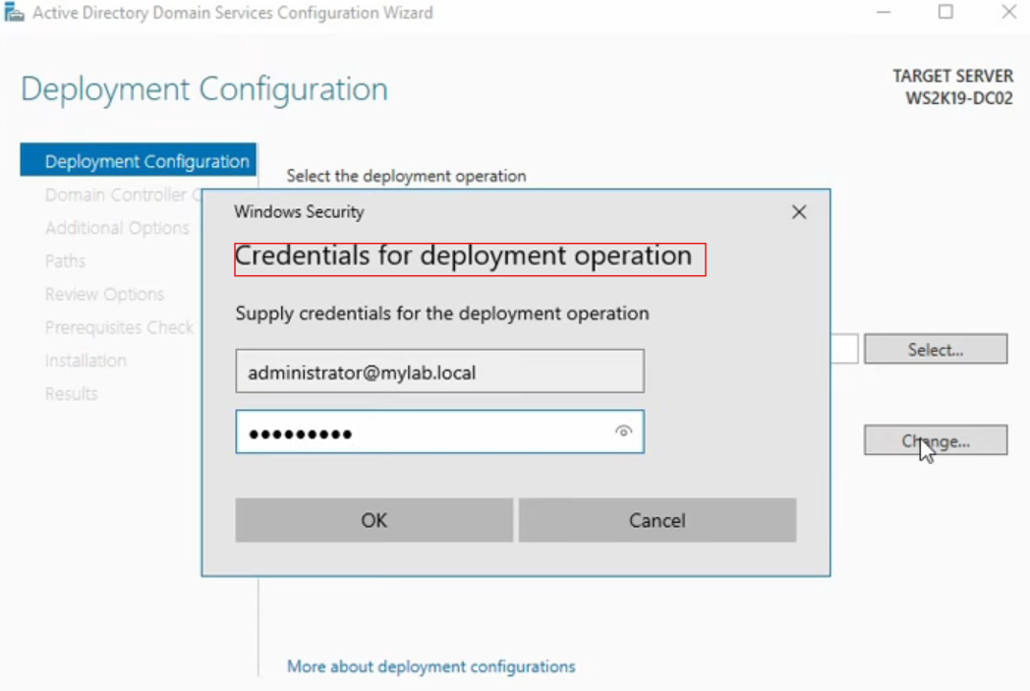
Step 5: Specify the domain information to add the domain controller to existing domain and Click Next
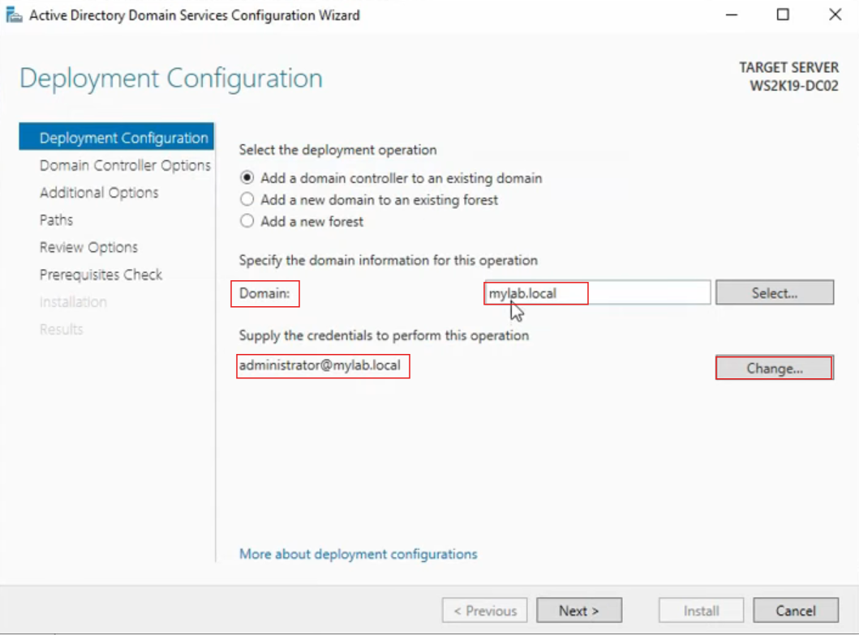
Step 6: Under Domain Controller Options, DNS Server and Global Catalog (GC) is selected. The First Site name will be “Default-First-Site-Name.” Enter Domain Controller DSRM Password.
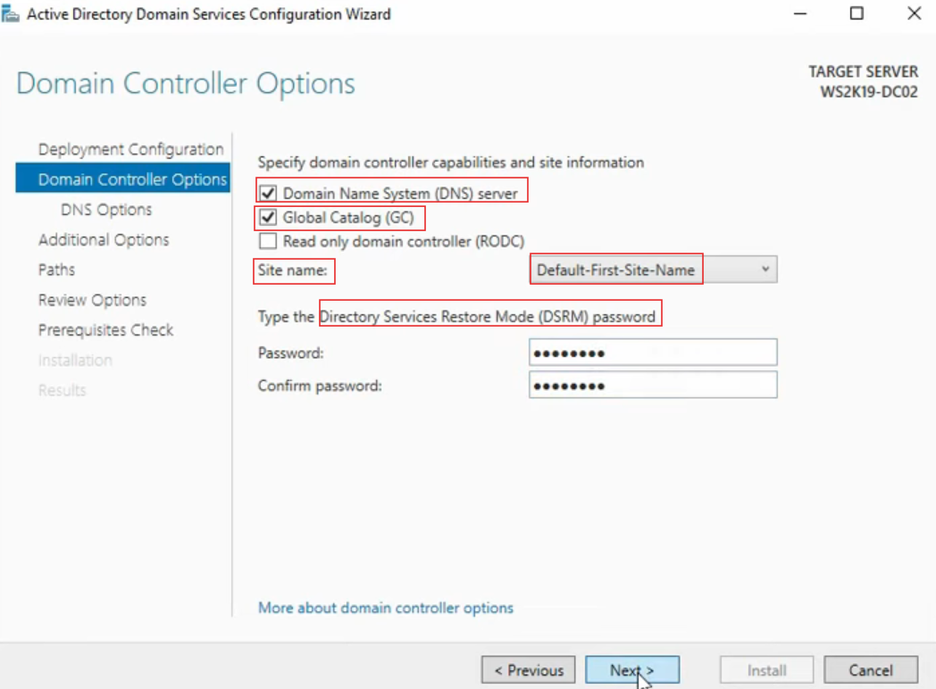
Step 7: Select Replicate from any Domain Controller or to a specified Domain Controller
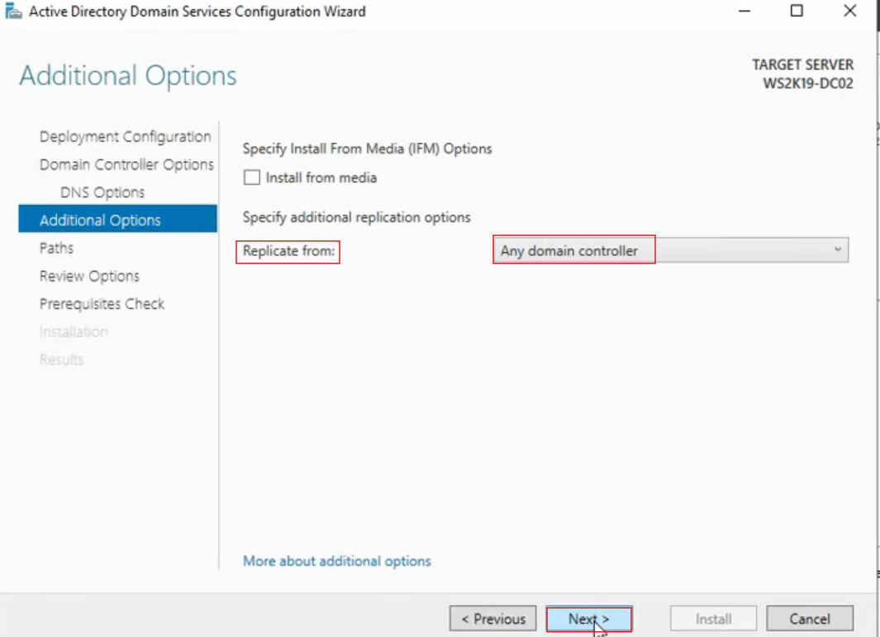
Step 8: The Database, Log Files and Sysvol Folder is stored in “C” \Windows\NTDS or SYSVOL” path
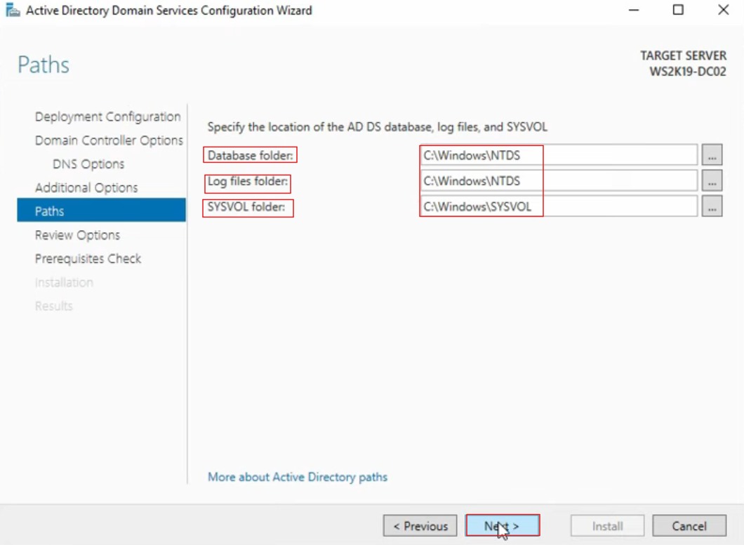
Step 9: All prerequisite checks passed successfully. Click “Install” to begin installation.
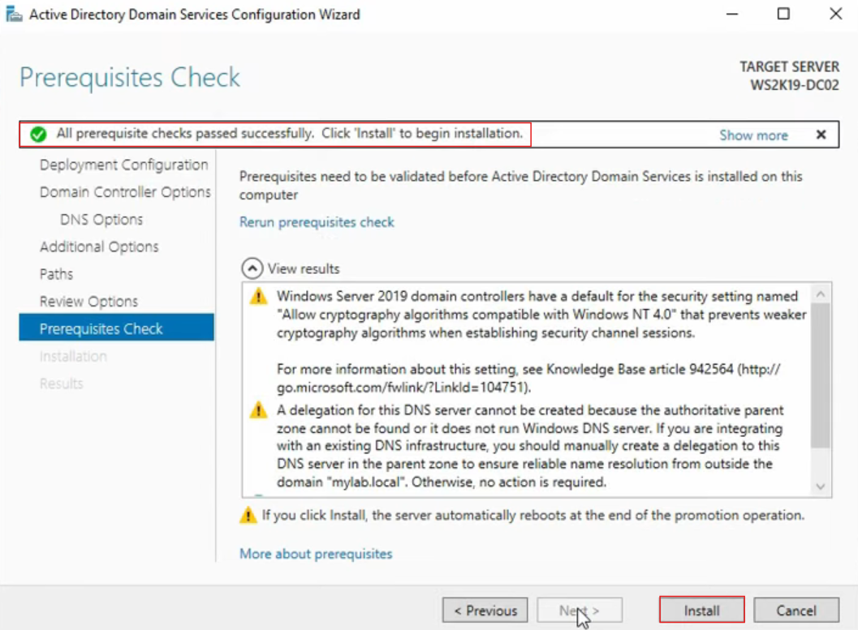
Step 10: In ADUC, under domain select Domain Controller to see DC’s
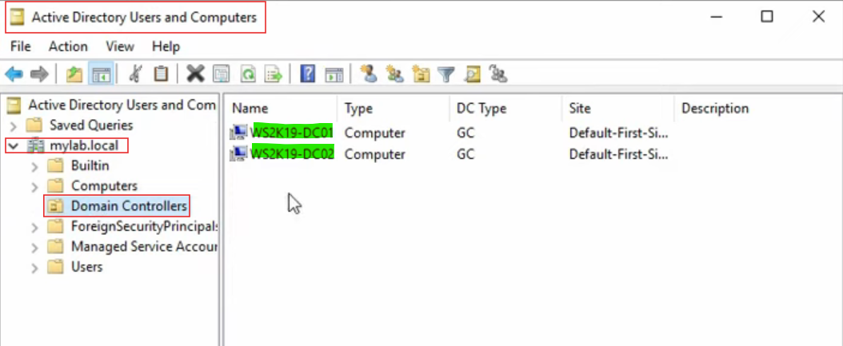
Step 11: Go to DNS management console, Under forward Lookup Zones mylab.local
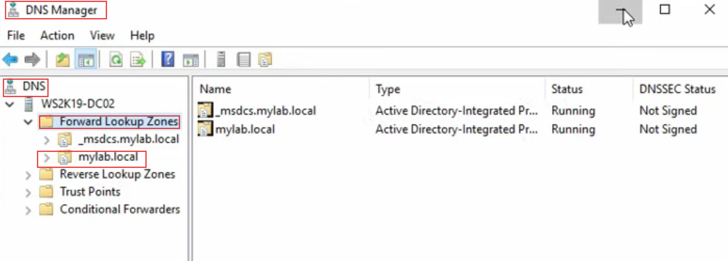
Step 12: In AD Sites and Services, under Default-First-Site-Name Under DC servers Select NTDS settings Right click properties All Tasks Check Replication Topology
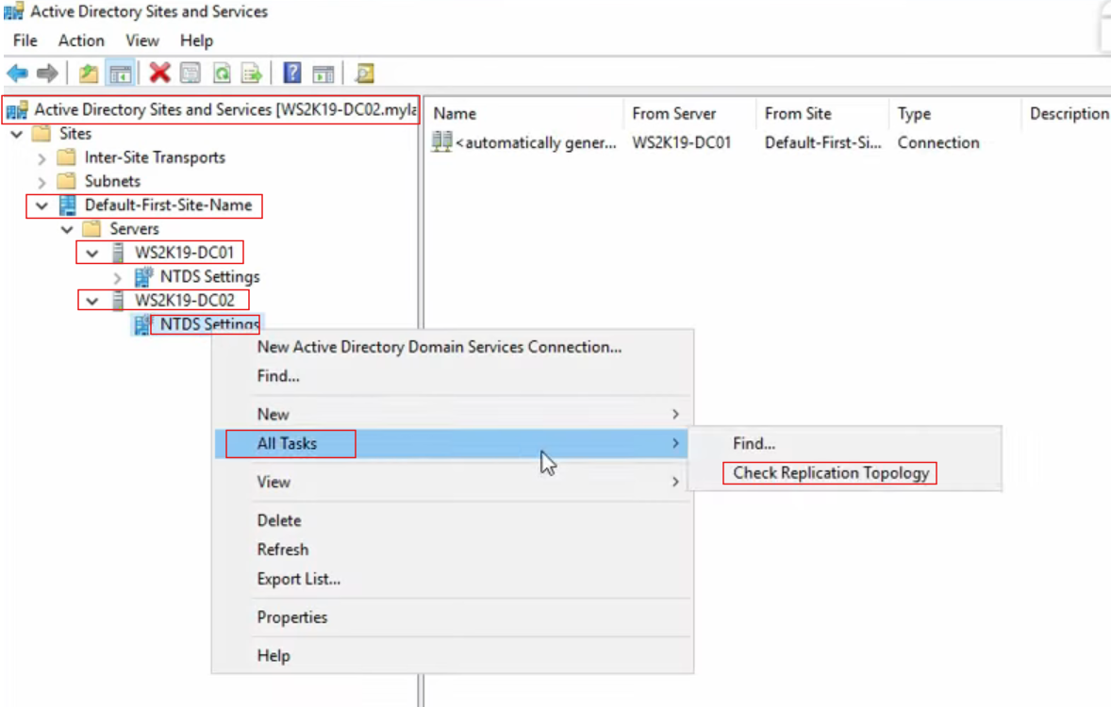
Step 13: The Domain Controller will be replicated.
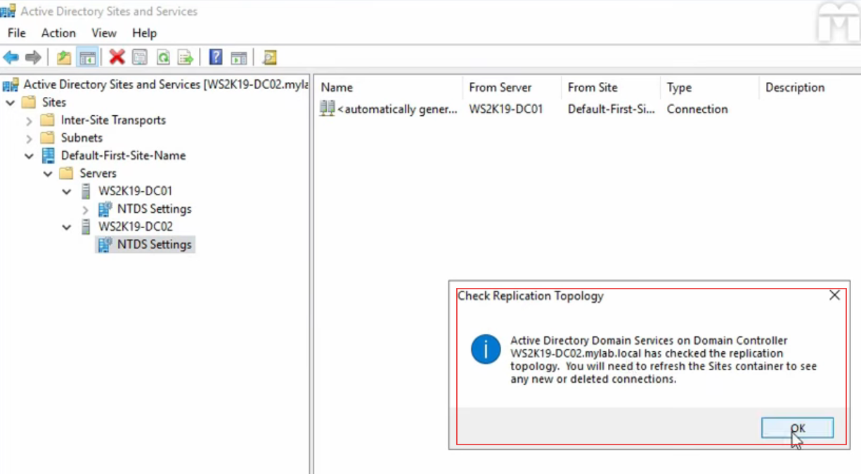
Step 14: In DC Sites Right click Select Replicate Now
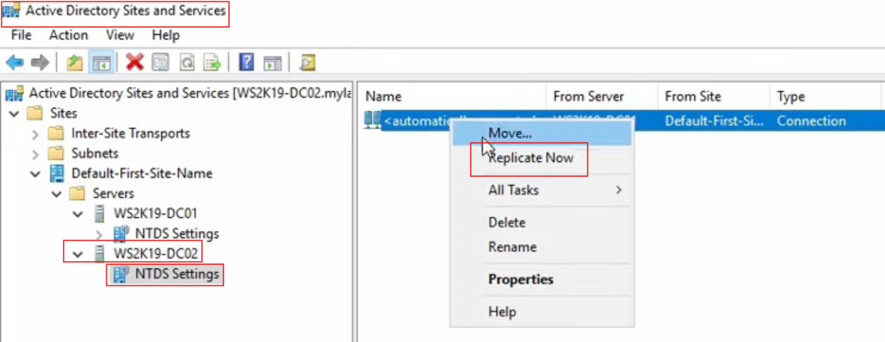
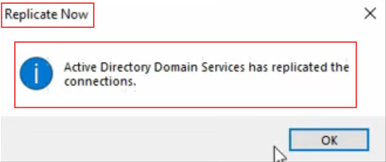
Step 15: In AD Sites and Services, Under NTDS Settings Properties, Check Replicate from and Replicate to DC’s
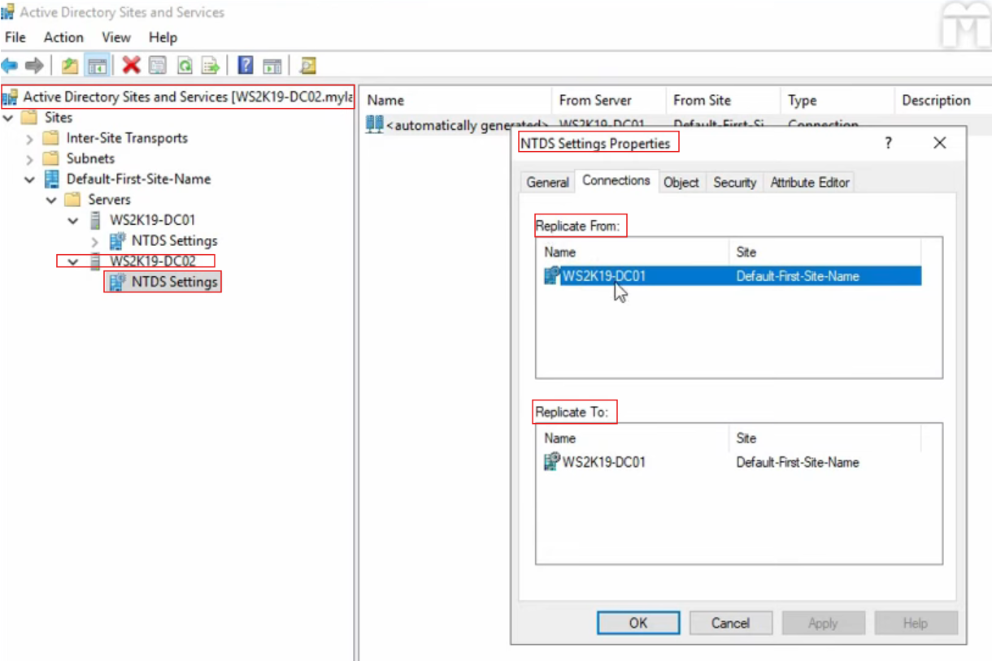
Step 16: To test replication between two domain controllers’, create a Test GPO1 in DC1 and check the Group Policy Test GPO1 is replicated in other domain controller DC02.
